Kilcock Community Garden
By Fionnuala Corcoran

In the beginning there wasn’t even a coherent idea, just a desire to do something for biodiversity and to address the food sustainability issue we face due to climate breakdown. I’d visited Rathcoffey Zerowaste Community Garden a couple of times and was very impressed with what they were doing there but I knew from talking to the founder Pat Pender that it had been a long hard solo slog to get it off the ground, and wouldn’t be something I could do.
Roll on a few months and we’re in lockdown, I spot a lovely video of Rathcoffey Zerowaste Community garden online and decide to share it asking “would we like something like this in Kilcock?” The post got a huge response, obviously hitting the right note at the right time. I wanted to capture that interest so immediately set up a Zoom meeting which happened on 13th May 2020. I also set up a facebook page and group which now have 215 followers and 107 members respectively.

At the meeting we all introduced ourselves, saying where in Kilcock we were from and why we were interested in the group. Most of the group are interested in growing food, a few are keen gardeners, some expressed wanting to build community, build resilience, get to know people in the community. A couple are on their resident’s association in their own estate. A couple have some experience in setting up community gardens in their workplace.
We then as a group carried out 2 exercises, Exercise 1 to brainstorm in general what community gardens in Kilcock might mean / look like / feel like. This exercise was to explore ‘what’ we would like and not to worry about the ‘how’ at this stage. This brainstorm was documented and can serve as a guide to our future plans. Exercise 2 was then to explore in particular the project of the Bawnogue Community Garden as an initial project and discuss what this could look like and what would be required for this to happen.

These are the results of the brainstorm of ideas from the group. This will form a guide to our future plans.

Allotments, Vegetable patches, Fruit trees and bushes, nut trees, Community composting, Rainwater harvesting, Flower beds, Walking Pathways, Walkways, Encourage people to get involved, participate, talk about, Getting people to stop and think, Signage – education about growing, about biodiversity, Plaques per garden, Biodiversity friendly gardens, bug and bee hotels, Use of wood, Bench, seat – contemplative space, Accessibility, Seasonal, Recycle things we already have, e.g. to grow things in, Themed gardens – each one could have a different theme – maybe, herb, fruit, vegetable, flower, bee garden, butterfly garden, insect friendly garden, wetlands, and whimsical themes using garden furniture and planting to create magical spaces.
Could have lots of community gardens around Kilcock, one in every estate.
Create ‘a gardens walk’, Garden walk – from garden to garden and map, could become a tourist attraction, local community activities – doing the gardens walk, run, child friendly, educational. Maps and signage showing distance to next garden. Link to the Sli na Slainte walk.
Match soil in different gardens to different products, Greening of the town – Have much more planting and greenery in the town, including rooftop and vertical gardens – check out resources on urban greening, Market – sell produce from garden, Create a community Co-op – CSA – Community Supported Agriculture, Polytunnel, Use Bawnogue or commons land. Seed library, Link in with schools and community groups, Orchards – in every estate, Fruit bushes – all over Kilcock – in estates. Festivals, Community Apple Press – Apple juice/vinegar/cider, Utilise skills of older people – teach the community, Involve the Men’s sheds as they have lots of expertise and skills, Same for ICA,
Wild flower meadows, Bee hives, Develop further the community garden in the square – this might be do-able reasonably quickly, Develop goals, Short and medium and long term plans, Get started quickly on short term, achievable and simple.

So, as you can see we are an ambitious group. We are very lucky to have an existing space in Kilcock that we can start with. We asked Kildare County Council if we could develop this space as a community garden and they were happy to give the go ahead, and we got lots of good ideas and advice from KCC environmental officer. If we hadn’t had this space, I think we would have tried collaborating with one of the resident’s associations to start in one of the estates.

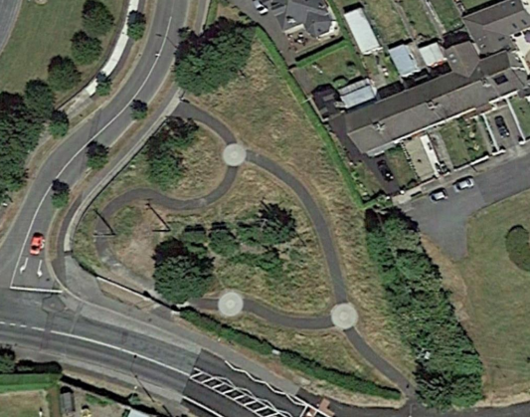
Kilcock Tidy towns agreed to take the Community Gardens group under its wing, making it a sub-group of Tidy Towns, which makes things easier all round. Tidy Towns funded us to buy some wood and topsoil/compost to put in some beds. After several mistakes by me in the calculations for cutting up the wood we finally got it right and a couple of members cut the wood into the right sizes to make the beds. We met up in the gardens on 23/6/20 and put the beds together, lined the bottom of them with cardboard and then filled them with the topsoil.

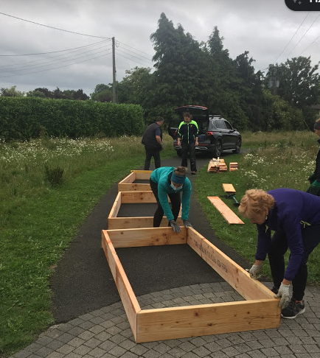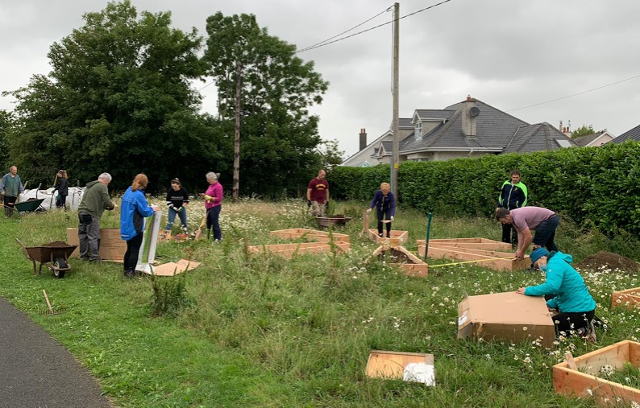

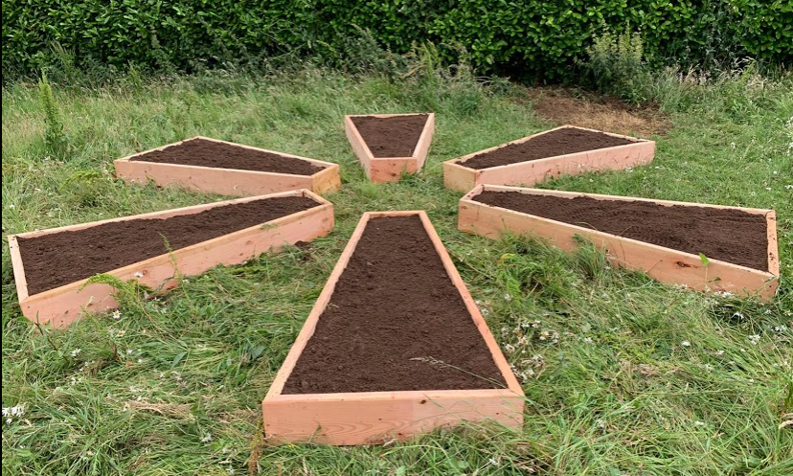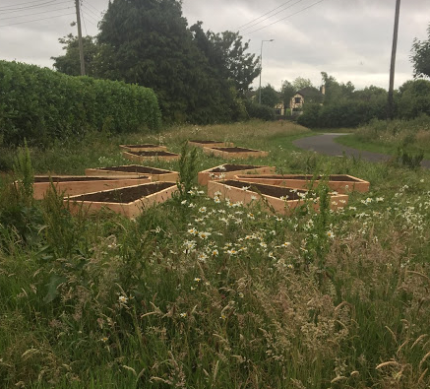

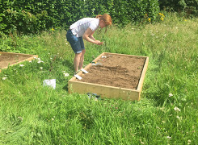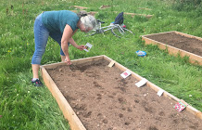

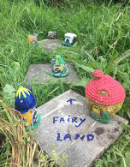

We made a feature circular herb bed (mint, camomile, thyme, rosemary, sage, oregano, lemon balm, parsley, chives, watercress, fennel) and a few other small raised beds for vegetables. These were all planted up in spring /summer 2020 and are doing well. We were donated some little fairy houses which we repainted and put up in the garden. They are currently being very much enjoyed by the children passing through and we hope are the start of a much better fairy garden area.
We were a at a bit of hiatus then, with not much happening in the garden, and we weren’t sure what to do next, at the suggestion of one of the group we decided to organise to meet up every Saturday in the garden and see what happened. Having a regular time worked well and we now have 8-10 regulars who work in the garden.
In October, Ursula King, resident of Kilcock and expert in permaculture and horticulture joined our group. In addition, we have another expert, Mario Vidak, also resident in Kilcock join our group. They have put together a detailed plan based on permaculture methods for the garden. In October / November we began to prepare permaculture beds. We put a call out to the community, and they are helping by bringing us cardboard and leaves / clippings to use. We are keeping everyone abreast of our progress via our WhatsApp group (30 members)
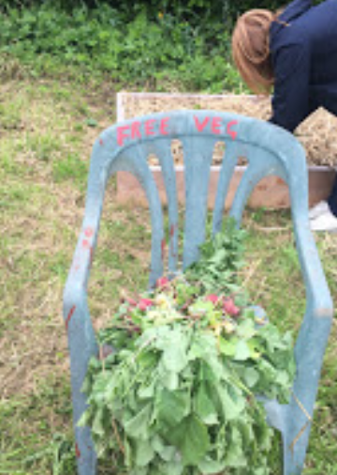
Our first harvest – radishes
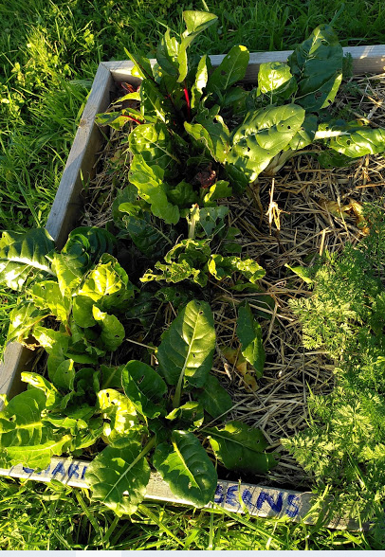
Swiss chard doing well

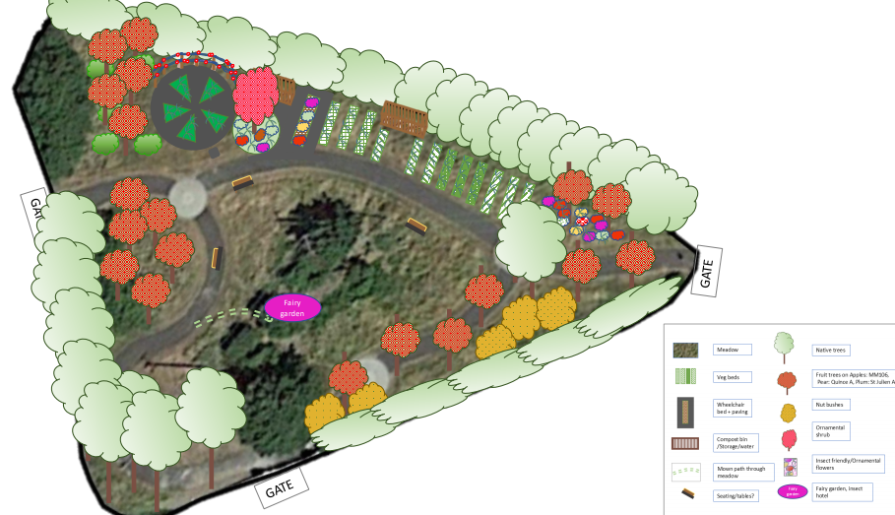
Plan for the garden.

Our plan includes pollinator friendly flower beds, vegetable beds, orchard area with fruit trees and an under canopy of fruit bushes, further planting of native Irish trees, planting of pollinator friendly native Irish plants like honeysuckle and ivy around the perimeter, installation of a compost area, with separate leaf compost area, installation of small greenhouse so we can propagate our own plants, installation of tool storage area, installation of IBC container for water and rainwater harvesting from greenhouse and possibly from IBC container surround, installation of wheelchair accessible raised bed area, installation of children’s play / mud station area, installation of children’s fairy garden/ imaginative space and/or sensory garden area, installation of produce stall, signage to explain and educate, along with development of website and blog, detailing all our steps to allow the model to be replicated. We also plan to run workshops in this space and have already planned for 2 workshops in the spring 1) to build compost bins and make compost, and 2) to build bug hotels. We plan to make/re-use items as much as possible and be as self-sufficient as possible (for example, we will begin seed saving and set up a seed swap library).
Several people in the group have some woodworking skills and we plan to build our own installations as far as possible.
We currently meet up in the garden every Saturday. Part of the work we do there is to talk to passers-by and engage them in discussion about what we are doing and encourage them to become involved. The group that are working there presently are learning about permaculture, biodiversity and how to plan gardens, thereby building capacity, and facilitating them to create something similar in the future.
Our longer-term plan is to engage with Residents Associations and any other interested groups in the town, to roll out and promote community gardens throughout the town.

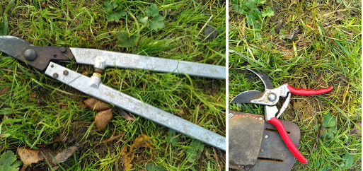
Buy well and buy once! Swiss made – brand Felco, tools owned by Ursula for over 30 years and still perfect.

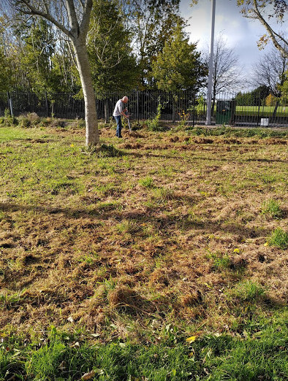
Removing the cut grass October 2020 – A wild flower meadow needs to have the long grass removed, in order to reduce the fertility of the soil, which will help the wild flowers grow.

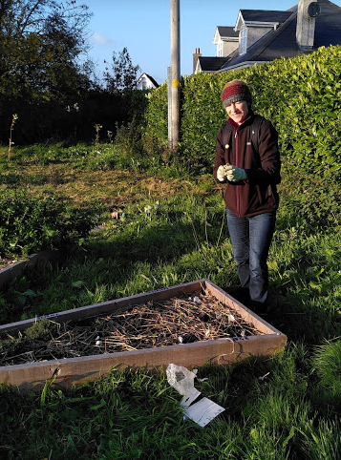
Planting garlic at the end of October 2020

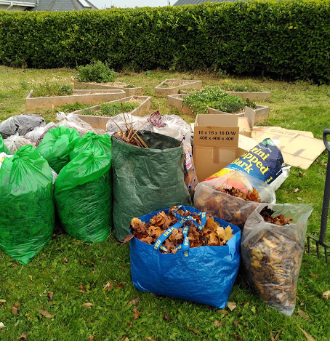
Bags of leaves brought up by members of the community for our permaculture beds
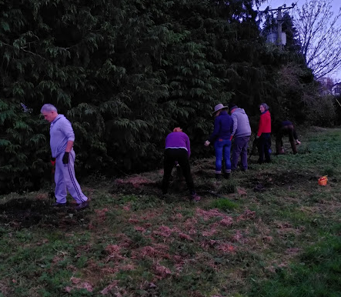

Forking out the scutch grass and creeping buttercup November 2020

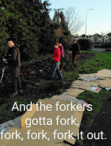

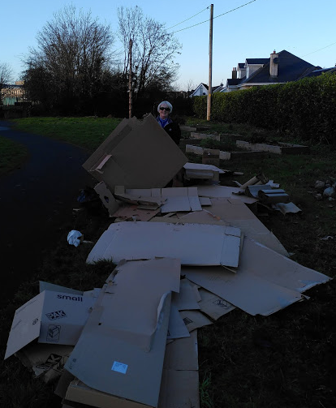
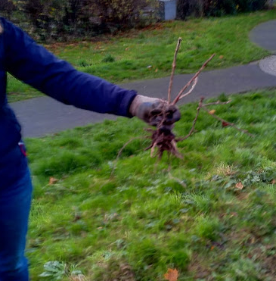
If you don’t remove the scutch grass it will keep coming back.

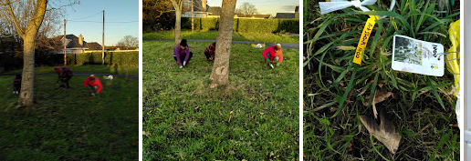
Planting some pollinator friendly spring bulbs (funded by Tidy Towns)

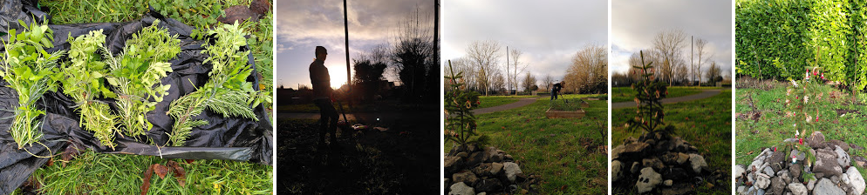
We gave lots of Christmas herbs for stuffing to members of the community + our little scavenged Christmas tree.

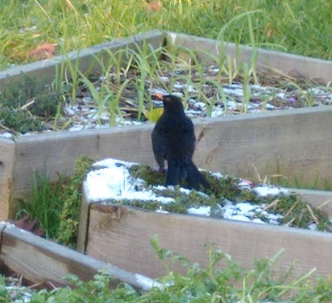
We get lots of visitors
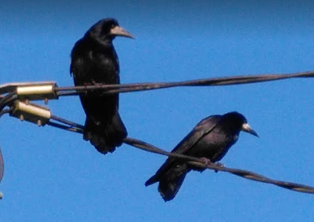
We have a couple of caretakers who watch over the garden for us!
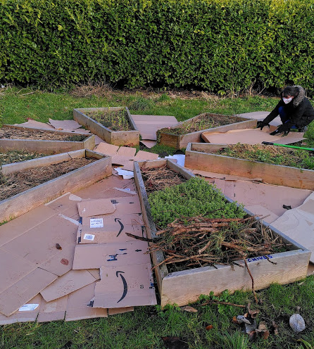
Preparing the herb beds for paths. January 2021

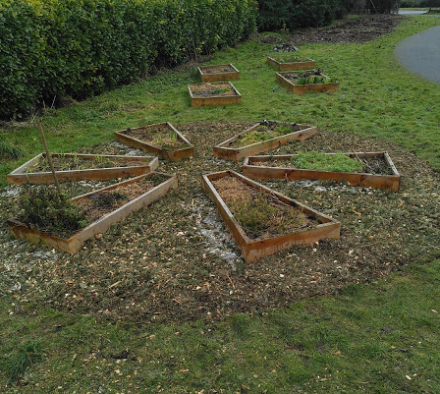
Using up the shredded Christmas trees to make paths around the herb bed.

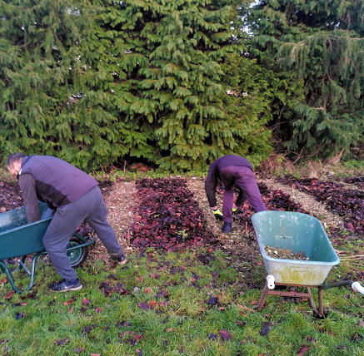
Putting in paths in out permaculture vegetable bed.
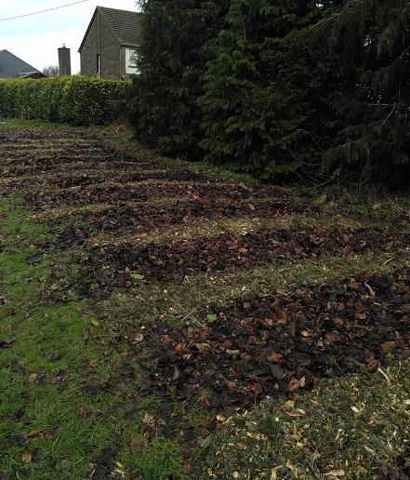

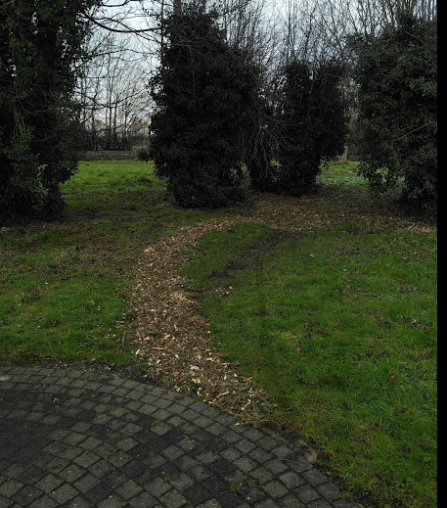
More paths made. Curvy paths are so much better. January 2021

